Welcome
Trinity Lutheran Church
Lutheran Church—Missouri Synod
A Stephen Ministry Congregation

1354 South Otsego Avenue
Gaylord, Michigan 49735
Church Phone: (989) 732-4816

Church Email: secretary@trinitygaylord.com
www.trinitygaylord.com

Office Hours: Monday through Friday 9am – 1pm

OUR PURPOSE
…is to LOVE GOD, LOVE OTHERS, AND SERVE THE WORLD by worshiping the Lord Jesus, bringing our members into Christ-like maturity, and equipping them through Word and Sacrament for their mission and ministry. We go heart to heart into the world with Jesus, sharing His love, caring for one another, praying, and bringing the lost into a relationship with Christ, by the working of the Holy Spirit.

January 23, 2022
(Second Sunday after the Epiphany)
Preacher: Rev. Paul Schneider

ABOUT OUR WORSHIP
We welcome all who gather here today! We are blessed to celebrate together the mercy, grace, and love we have from God through the death and resurrection of our Lord Jesus Christ.

Children: Families with children are very welcome here. Having children in church is important so they can begin to learn about their faith in Jesus, and it’s good for the whole congregation to see. Please feel comfortable keeping “squirmy” kids in the service. This is where they belong, too!

Pew Cards: Guests and Members, please fill out the Guest/Member card located on the back of the pew in front of you and pass it to the end of the aisle. If you forget you can put it in the offering plate on your way out.

If standing is difficult: Please feel free to remain seated during any portion of the service. Please let an Elder or Usher know if you need communion in your pew seat.

About our celebration of Holy Communion: We celebrate the Lord’s Supper in the confession and glad confidence that, as he says, our Lord gives into our mouths not only bread and wine but his very body and blood to eat and to drink for the forgiveness of sins and to strengthen our union with him and with one another. Our Lord invites to his table those who trust his words, repent of all sin, and set aside any refusal to forgive and love as he forgives and loves us, that they may show forth his death until he comes.

Because those who eat and drink our Lord’s body and blood contrary to that which is stated above do so to their great harm, and also because Holy Communion is a confession of the faith which is confessed at this altar. Anyone who is not yet instructed, in doubt, or who hold a confession differing from that of the Lutheran Church—Missouri Synod, and yet desire to receive the sacrament, are asked first to speak with Pastor. Those not communing are still invited to come forward for a blessing from Pastor, and you may indicate this by crossing your arms over your chest.
TTTTTT

GREETING

P Peace be with you.
C And also with you.
T ORDER OF SERVICE T
(The liturgy is from Divine Service Setting four LSB pg. 203ff)

OPENING HYMN

Lord Jesus Christ, Be Present Now LSB 902 (Please stand on v.4 )
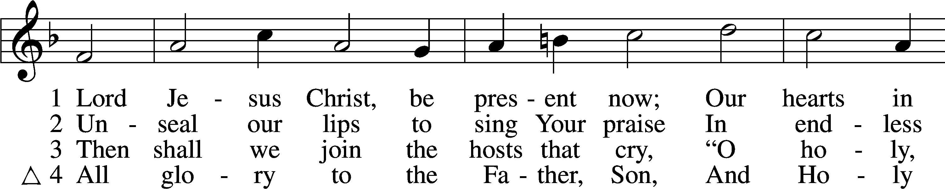
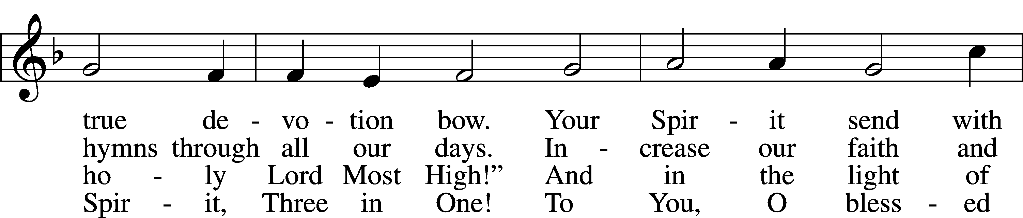
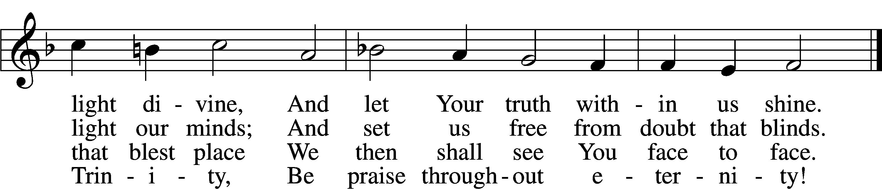
Text and tune: Public domain

CONFESSION and ABSOLUTION

The sign of the cross may be made by all in remembrance of their Baptism.

P In the name of the Father and of the T Son and of the Holy Spirit.
C Amen.
P Our help is in the name of the Lord,
C who made heaven and earth.

P If You, O Lord, kept a record of sins, O Lord, who could stand?
C But with You there is forgiveness; therefore, You are feared.

P Since we are gathered to hear God’s Word, call upon Him in prayer and praise, and receive the body and blood of our Lord Jesus Christ in the fellowship of this altar, let us first consider our unworthiness and confess before God and one another that we have sinned in thought, word, and deed, and that we cannot free ourselves from our sinful condition. Together as His people let us take refuge in the infinite mercy of God, our heavenly Father, seeking His grace for the sake of Christ, and saying: God, be merciful to me, a sinner.
C Almighty God, have mercy upon us, forgive us our sins, and lead us to everlasting life. Amen.
P Almighty God, merciful Father, in Holy Baptism You declared us to be Your children and gathered us into Your one, holy Church, in which You daily and richly forgive us our sins and grant us new life through Your Spirit. Be in our midst, enliven our faith, and graciously receive our prayer and praise; through Your Son, Jesus Christ, our Lord.
C Amen.

INTROIT Psalm 102:18–22; antiphon: v. 13
P You will arise and have pity on Zion;
it is the time to favor her; the appointed time has come.
C Let this be recorded for a generation to come,
so that a people yet to be created may praise the Lord:
P that he looked down from his holy height;
from heaven the Lord looked at the earth,
C to hear the groans of the prisoners,
to set free those who were doomed to die,
P that they may declare in Zion the name of the Lord,
and in Jerusalem his praise,
C when peoples gather together,
and kingdoms, to worship the Lord.

Glory be to the Father and to the Son
and to the Holy Spirit;
as it was in the beginning,
is now, and will be forever. Amen.

P You will arise and have pity on Zion;
it is the time to favor her; the appointed time has come.

SERVICE OF THE WORD
KYRIE LSB 204
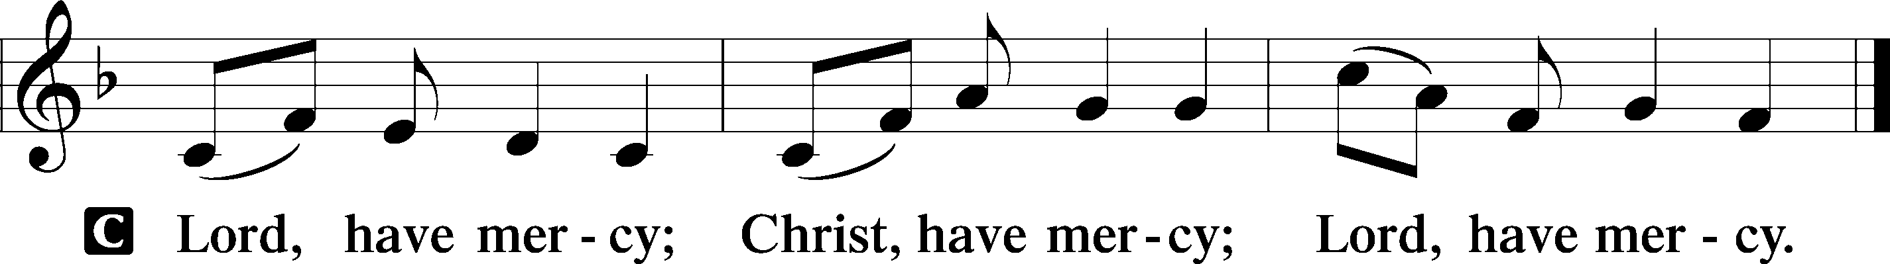

HYMN OF PRAISE
GLORIA in EXCELSIS LSB 204
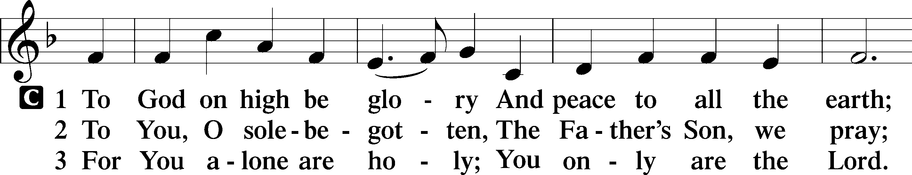
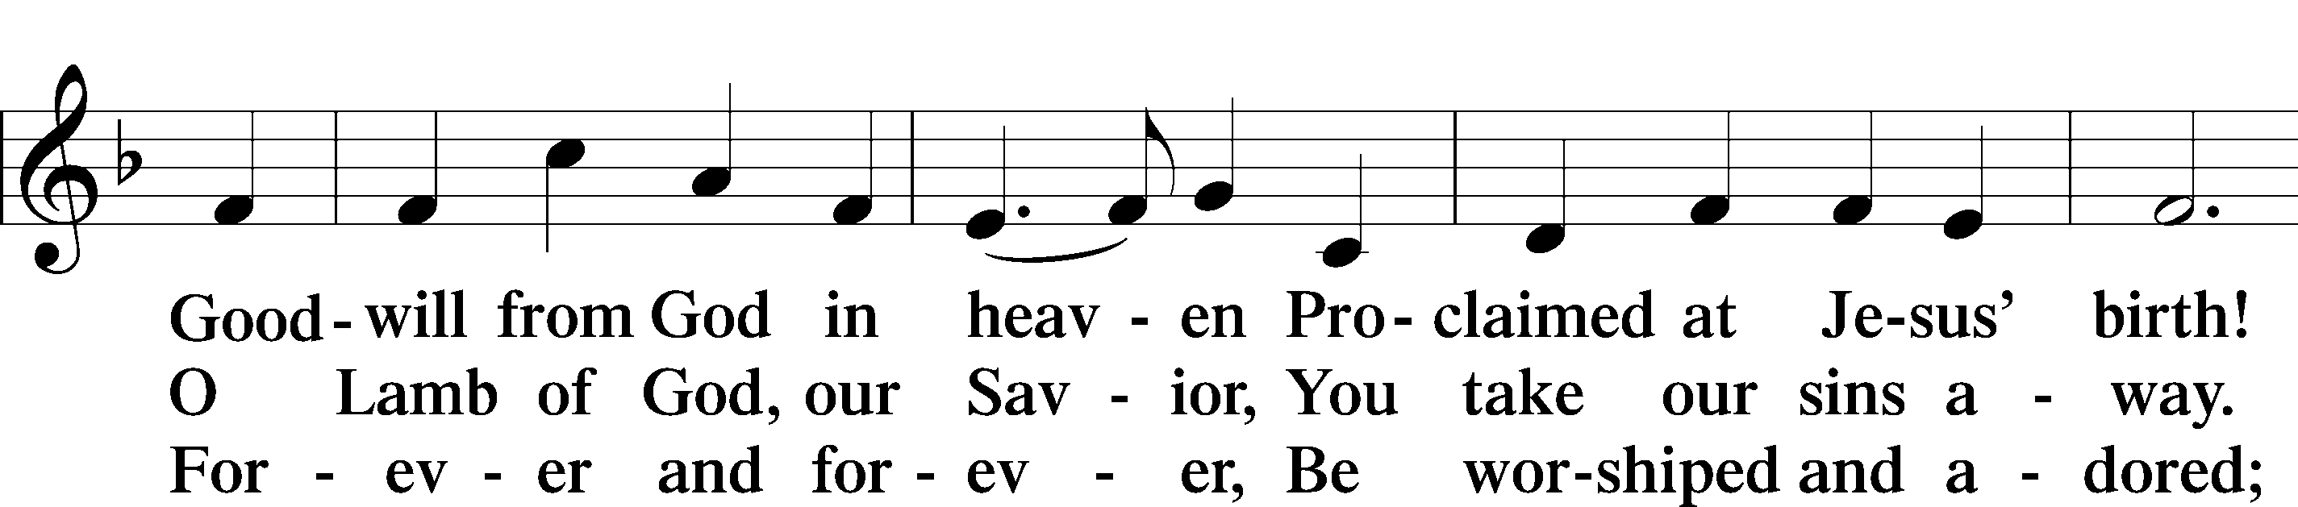
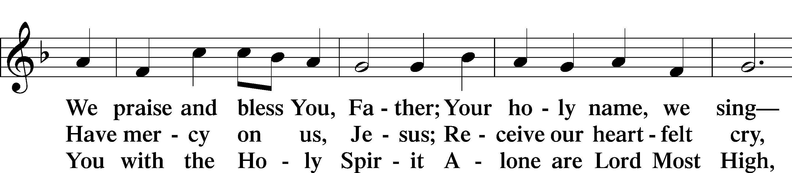
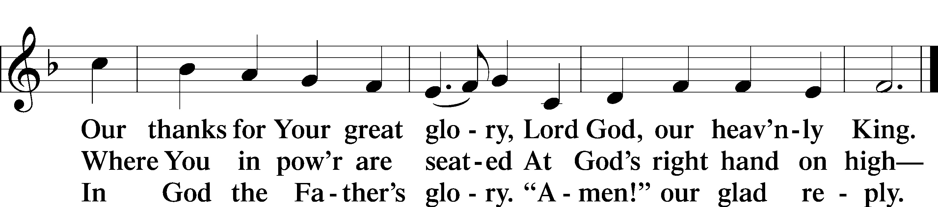

SALUTATION and COLLECT of the DAY
P The Lord be with you.
C And also with you.

P Let us pray.
Almighty and everlasting God, mercifully look upon our infirmities and stretch forth the hand of Your majesty to heal and defend us; through Jesus Christ, Your Son, our Lord, who lives and reigns with You and the Holy Spirit, one God, now and forever.
C Amen.

Please be seated

OLD TESTAMENT Psalm 19
¹The heavens declare the glory of God,
and the sky above proclaims his handiwork.
²Day to day pours out speech,
and night to night reveals knowledge.
³There is no speech, nor are there words,
whose voice is not heard.
⁴Their measuring line goes out through all the earth,
and their words to the end of the world.
In them he has set a tent for the sun,
⁵which comes out like a bridegroom leaving his chamber,
and, like a strong man, runs its course with joy.
⁶Its rising is from the end of the heavens,
and its circuit to the end of them,
and there is nothing hidden from its heat.
⁷The law of the Lord is perfect,
reviving the soul;
the testimony of the Lord is sure,
making wise the simple;
⁸the precepts of the Lord are right,
rejoicing the heart;
the commandment of the Lord is pure,
enlightening the eyes;
⁹the fear of the Lord is clean,
enduring forever;
the just decrees of the Lord are true,
and righteous altogether.
¹⁰More to be desired are they than gold,
even much fine gold;
sweeter also than honey
and drippings of the honeycomb.
¹¹Moreover, by them is your servant warned;
in keeping them there is great reward.
¹²Who can discern his errors?
Declare me innocent from hidden faults.
¹³Keep back your servant also from presumptuous sins;
let them not have dominion over me!
Then I shall be blameless,
and innocent of great transgression.
¹⁴Let the words of my mouth and the meditation of my heart
be acceptable in your sight,
O Lord, my rock and my redeemer.
P This is the Word of the Lord.
C Thanks be to God.

EPISTLE 1 Corinthians 12:12–31a
¹²For just as the body is one and has many members, and all the members of the body, though many, are one body, so it is with Christ. ¹³For in one Spirit we were all baptized into one body—Jews or Greeks, slaves or free—and all were made to drink of one Spirit.
¹⁴For the body does not consist of one member but of many. ¹⁵If the foot should say, “Because I am not a hand, I do not belong to the body,” that would not make it any less a part of the body. ¹⁶And if the ear should say, “Because I am not an eye, I do not belong to the body,” that would not make it any less a part of the body. ¹⁷If the whole body were an eye, where would be the sense of hearing? If the whole body were an ear, where would be the sense of smell? ¹⁸But as it is, God arranged the members in the body, each one of them, as he chose. ¹⁹If all were a single member, where would the body be? ²⁰As it is, there are many parts, yet one body.
²¹The eye cannot say to the hand, “I have no need of you,” nor again the head to the feet, “I have no need of you.” ²²On the contrary, the parts of the body that seem to be weaker are indispensable, ²³and on those parts of the body that we think less honorable we bestow the greater honor, and our unpresentable parts are treated with greater modesty, ²⁴which our more presentable parts do not require. But God has so composed the body, giving greater honor to the part that lacked it, ²⁵that there may be no division in the body, but that the
members may have the same care for one another. ²⁶If one member suffers, all suffer together; if one member is honored, all rejoice together.
²⁷Now you are the body of Christ and individually members of it. ²⁸And God has appointed in the church first apostles, second prophets, third teachers, then miracles, then gifts of healing, helping, administrating, and various kinds of tongues. ²⁹Are all apostles? Are all prophets? Are all teachers? Do all work miracles? ³⁰Do all possess gifts of healing? Do all speak with tongues? Do all interpret? ³¹But earnestly desire the higher gifts.

P This is the Word of the Lord.
C Thanks be to God.

Please stand as able
ALLELUIA AND VERSE LSB 205
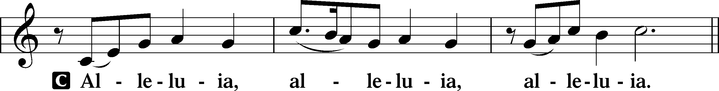

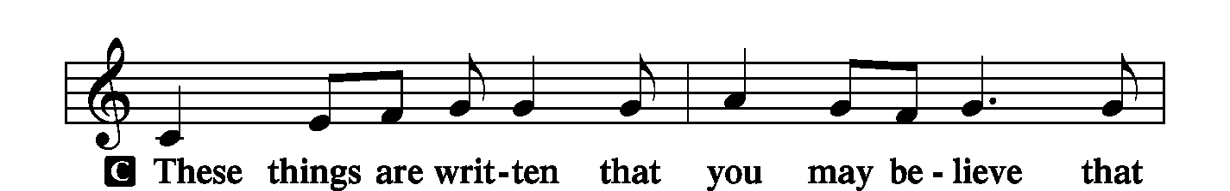
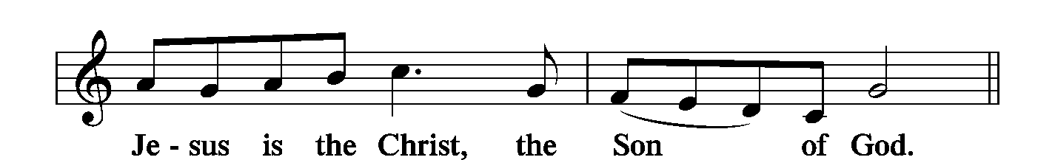
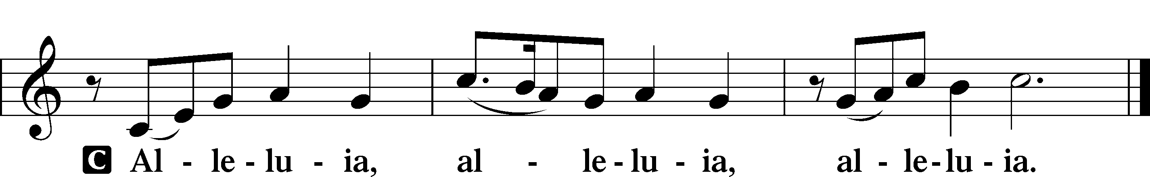

HOLY GOSPEL Luke 4:16–30
P The Holy Gospel according to St. Luke, the fourth chapter.
C Glory to You, O Lord.

¹⁶[Jesus] came to Nazareth, where he had been brought up. And as was his custom, he went to the synagogue on the Sabbath day, and he stood up to read. ¹⁷And the scroll of the prophet Isaiah was given to him. He unrolled the scroll and found the place where it was written,
¹⁸“The Spirit of the Lord is upon me,
because he has anointed me
to proclaim good news to the poor.
He has sent me to proclaim liberty to the captives
and recovering of sight to the blind,
to set at liberty those who are oppressed,
¹⁹to proclaim the year of the Lord’s favor.”
²⁰And he rolled up the scroll and gave it back to the attendant and sat down. And the eyes of all in the synagogue were fixed on him. ²¹And he began to sa y to them, “Today this Scripture has been fulfilled in your hearing.” ²²And all spoke well of him and marveled at the gracious words that were coming from his mouth. And they said, “Is not this Joseph’s son?” ²³And he said to them, “Doubtless you will quote to me this proverb, ‘Physician, heal yourself.’ What we have heard you did at Capernaum, do here in your hometown as well.” ²⁴And he said, “Truly, I say to you, no prophet is acceptable in his hometown. ²⁵But in truth, I tell you, there were many widows in Israel in the days of Elijah, when the heavens were shut up three years and six months, and a great famine came over all the land, ²⁶and Elijah was sent to none of them but only to Zarephath, in the land of Sidon, to a woman who was a widow. ²⁷And there were many lepers in Israel in the time of the prophet Elisha, and none of them was cleansed, but only Naaman the Syrian.” ²⁸When they heard these things, all in the synagogue were filled with wrath. ²⁹And they rose up and drove him out of the town and brought him to the brow of the hill on which their town was built, so that they could throw him down the cliff. ³⁰But passing through their midst, he went away.

P This is the Gospel of the Lord.
C Praise to You, O Christ.

NICENE CREED
C I believe in one God,
the Father Almighty,
maker of heaven and earth
and of all things visible and invisible.
And in one Lord Jesus Christ,
the only-begotten Son of God,
begotten of His Father before all worlds,
God of God, Light of Light,
very God of very God,
begotten, not made,
being of one substance with the Father,
by whom all things were made;
who for us men and for our salvation came down from heaven
and was incarnate by the Holy Spirit of the virgin Mary
and was made man;
and was crucified also for us under Pontius Pilate.
He suffered and was buried.
And the third day He rose again according to the Scriptures
and ascended into heaven
and sits at the right hand of the Father.
And He will come again with glory to judge both the living and the dead,
whose kingdom will have no end.
And I believe in the Holy Spirit,
the Lord and giver of life,
who proceeds from the Father and the Son,
who with the Father and the Son together is worshiped and glorified,
who spoke by the prophets.
And I believe in one holy Christian and apostolic Church,
I acknowledge one Baptism for the remission of sins,
and I look for the resurrection of the dead
and the life T of the world to come. Amen.

Please be seated

ALL GOD’S CHILDREN – TALK

HYMN OF THE DAY
Lord of All Good LSB 786 (Please stand on v.3)
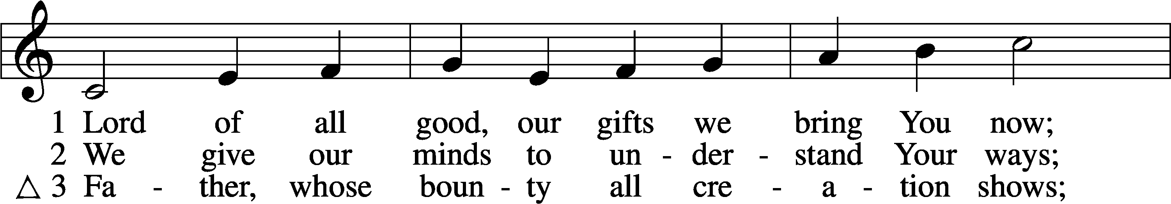
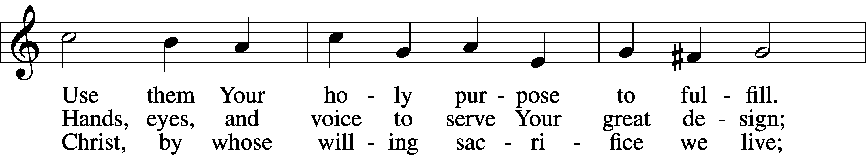
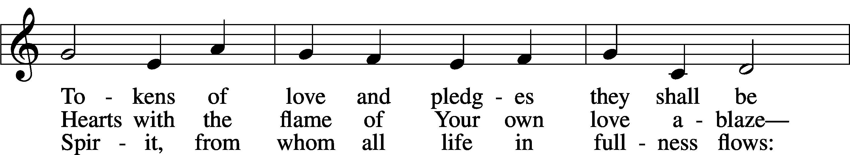
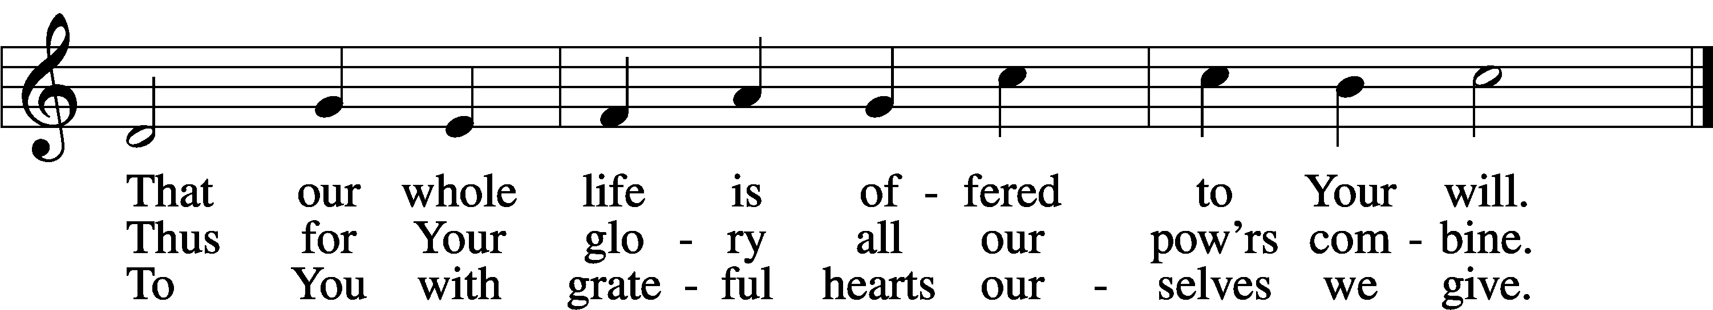
Text: © Oxford University Press. Used by permission: LSB Hymn License no. 110002537

SERMON

PRAYER of the CHURCH
After each Segment:
P Lord, in Your Mercy,
C Hear our Prayer.
After Final Segment:
P Hear us as we pray in His name and as He has taught us:
LORD’S PRAYER
C Our Father who art in heaven,
hallowed be Thy name,

Thy kingdom come,
Thy will be done on earth
as it is in heaven;
give us this day our daily bread;
and forgive us our trespasses
as we forgive those
who trespass against us;
and lead us not into temptation,
but deliver us from evil.
For Thine is the kingdom
and the power and the glory
forever and ever. Amen.

SERVICE of the SACRAMENT
Please stand as able

PREFACE LSB 208
P The Lord be with you.
C And also with you.
P Lift up your hearts.
C We lift them to the Lord.
P Let us give thanks to the Lord our God.
C It is right to give Him thanks and praise.
P It is truly good, right, and salutary that we should at all times and in all places give thanks to You, O Lord, holy Father, almighty and everlasting God, for the countless blessings You so freely bestow on us and all creation. Above all, we give thanks for Your boundless love shown to us when You sent Your only-begotten Son, Jesus Christ, into our flesh and laid on Him our sin, giving Him into death that we might not die eternally. Because He is now risen from the dead and lives and reigns to all eternity, all who believe in Him will overcome sin and death and will rise again to new life. Therefore with angels and archangels and with all the company of heaven we laud and magnify Your glorious name, evermore praising You and singing:

SANCTUS LSB 208
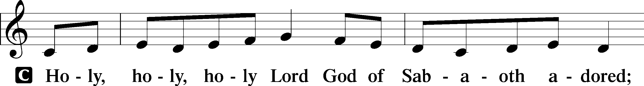
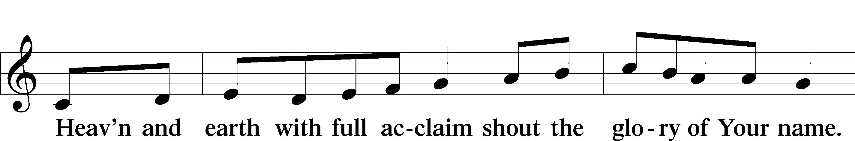
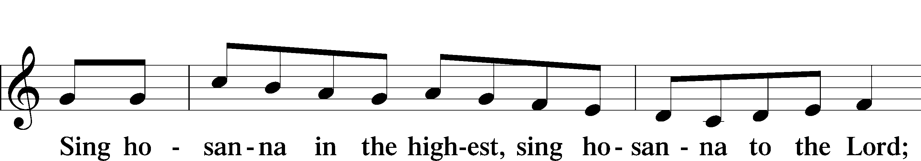

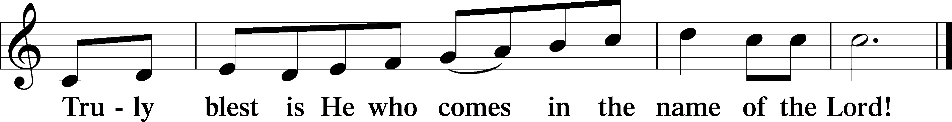

PRAYER OF THANKSGIVING
P Blessed are You, O Lord our God, king of all creation, for You have had mercy on us and given Your only-begotten Son that whoever believes in Him should not perish but have eternal life.

As the glory of Your presence once filled Your ancient temple, so in the incarnation of Your Son, Jesus Christ, You manifested the fullness of Your glory in human flesh.

We give You thanks that in His most Holy Supper You reveal Your glory to us. Grant us faithfully to eat His body and drink His blood so that we may one day behold Your glory face to face.

THE WORDS OF OUR LORD
P Our Lord Jesus Christ, on the night when He was betrayed, took bread, and when He had given thanks, He broke it and gave it to the disciples and said: “Take, eat; this is My T body, which is given for you. This do in remembrance of Me.”
In the same way also, He took the cup after supper, and when He had given thanks, He gave it to them, saying: “Drink of it, all of you; this cup is the New Testament in My T blood, which is shed for you for the forgiveness of sins. This do, as often as you drink it, in remembrance of Me.”

PAX DOMINI
P The peace of the Lord be with you always.
C Amen.
AGNUS DEI
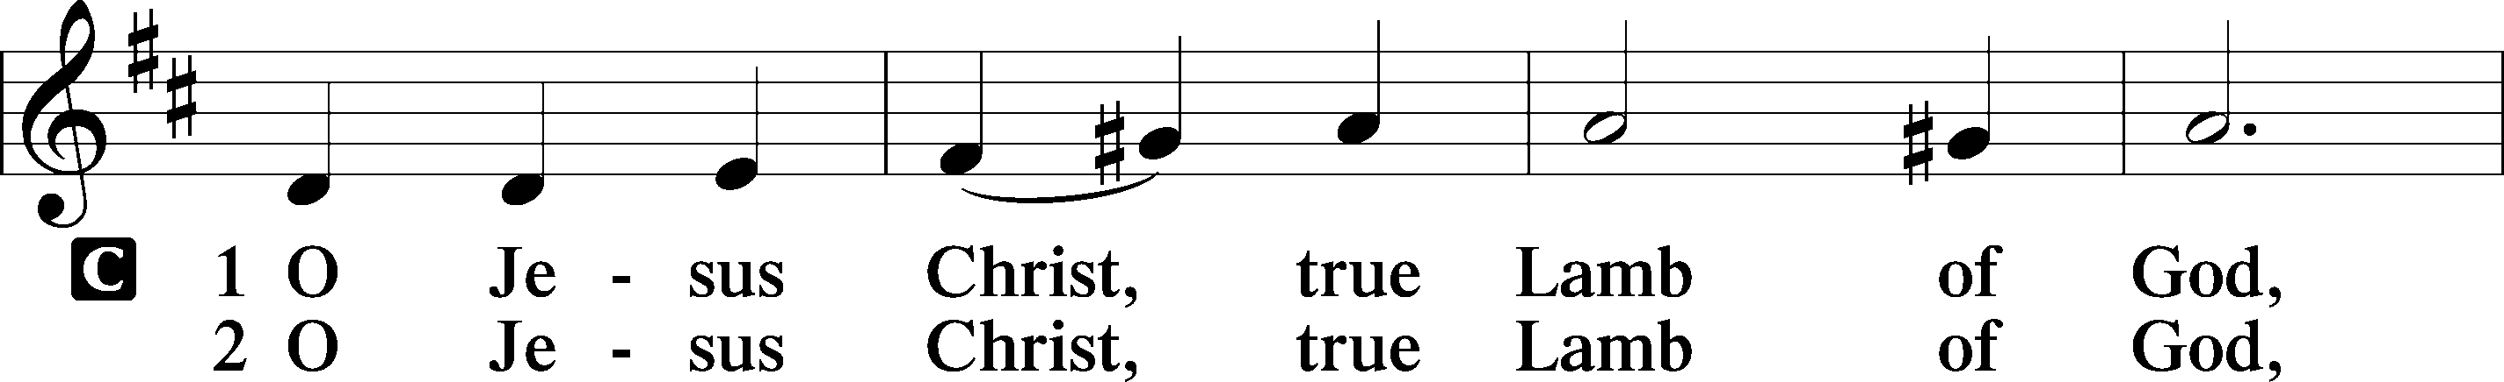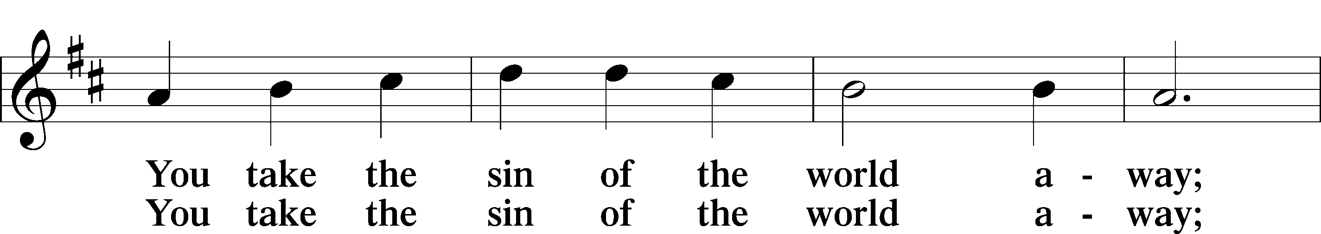
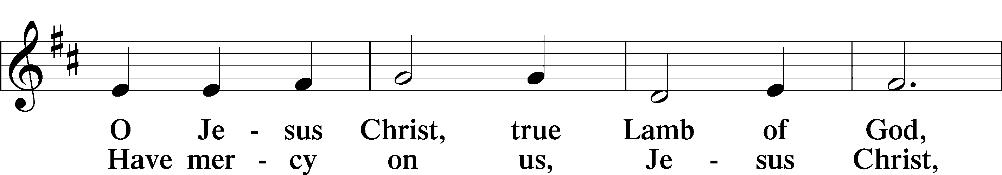
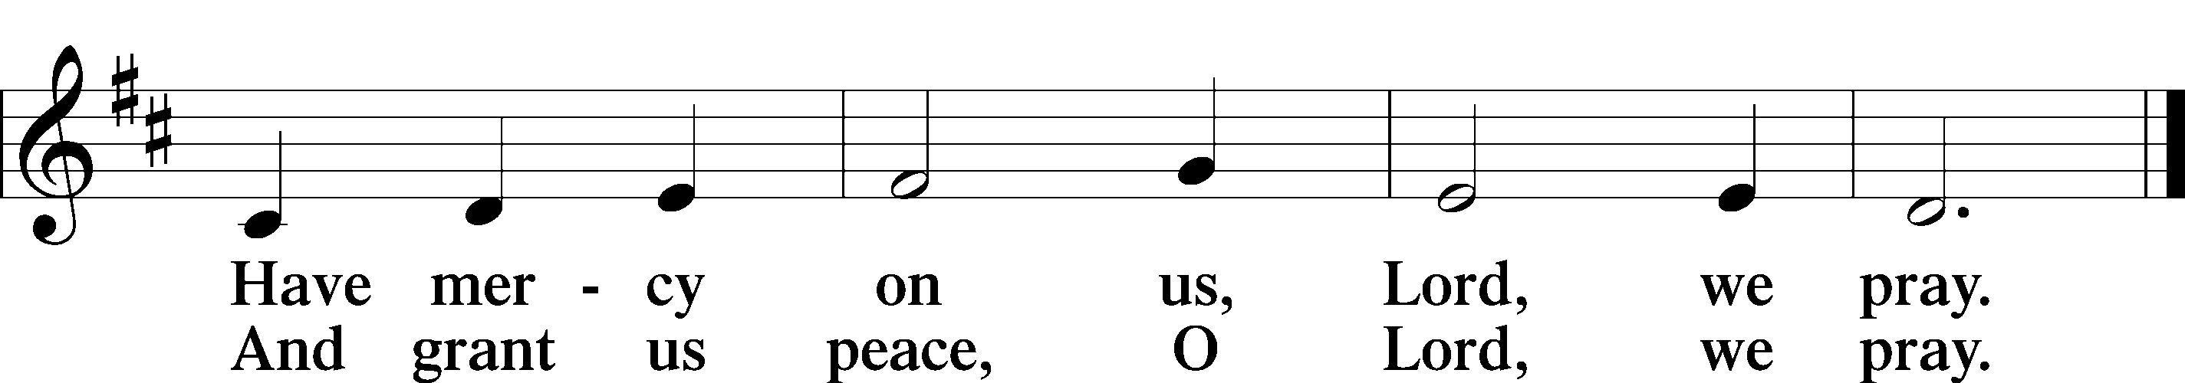

Please be seated
DISTRIBUTION
The pastor and those who assist him receive the body and blood of Christ first, then Communion will be served in a continuous fashion. Households may commune at the same time together. Ushers will help direct you forward via the center aisle; please return to your seats via the side aisles. Gluten-free bread is available for those who need it, as is non-alcoholic grape juice. Simply request either when you come forward to receive Communion.

DISTRIBUTION HYMN
Lord Jesus Christ, You Have Prepared LSB 622
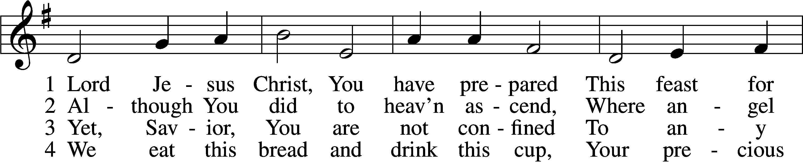
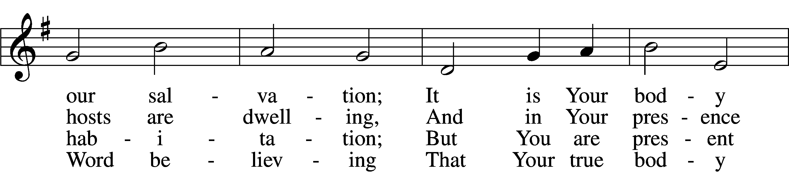
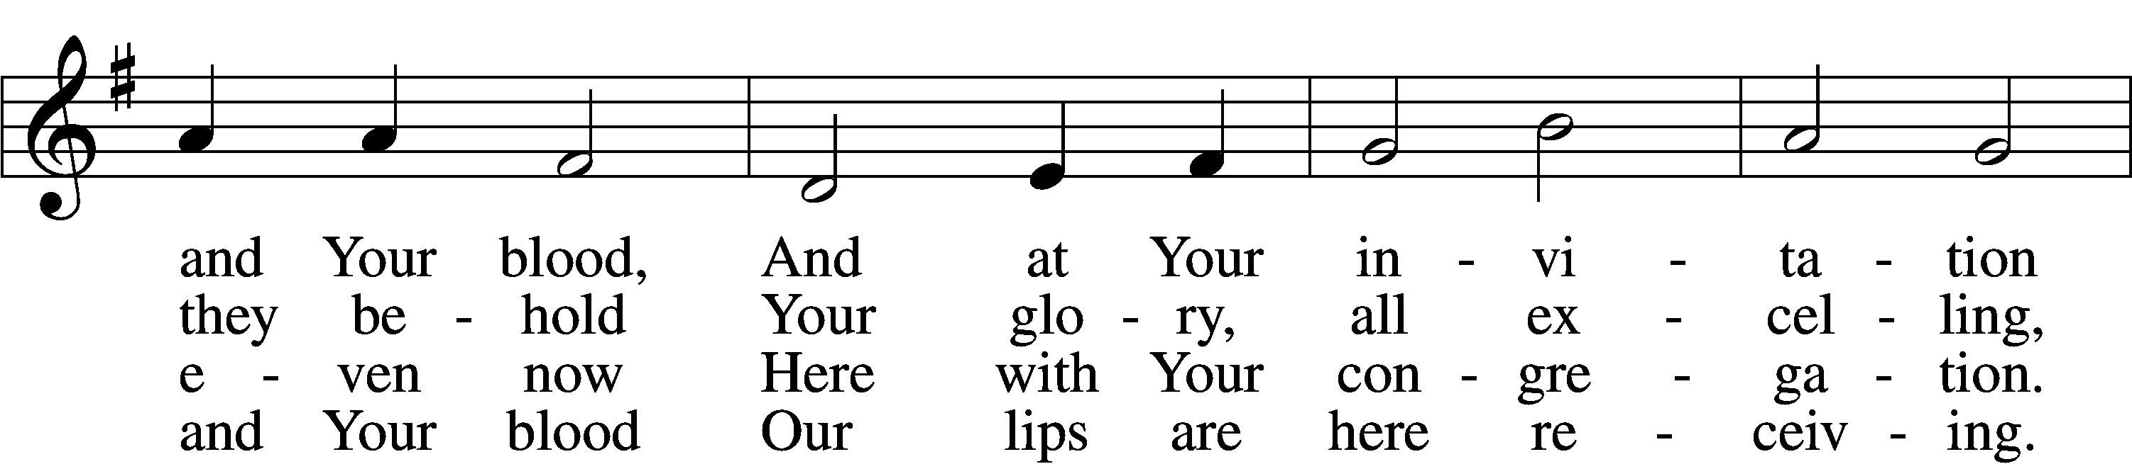
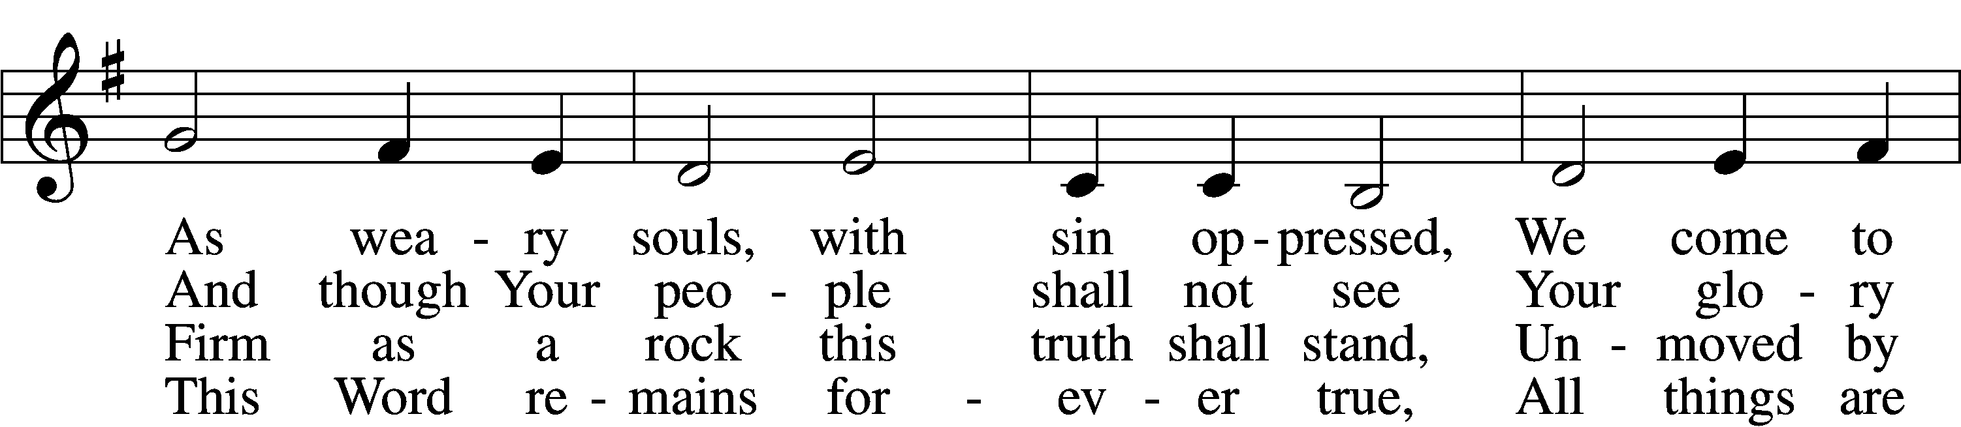
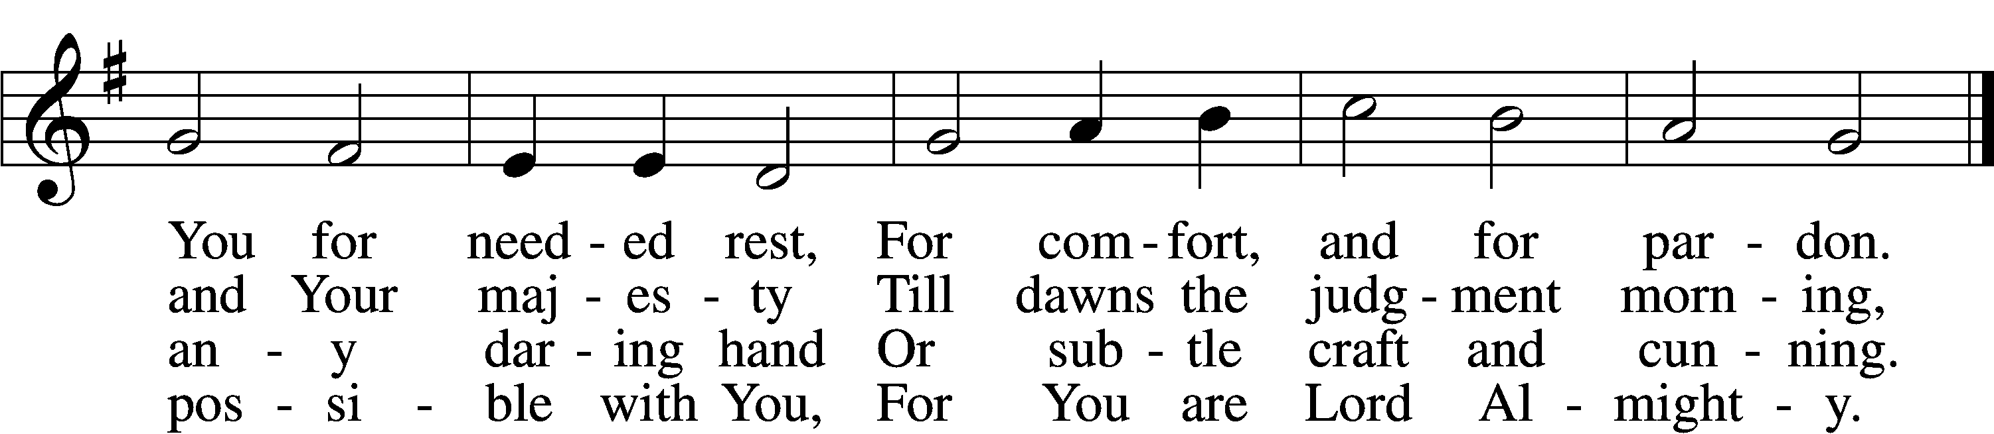

5 Though reason cannot understand,
Yet faith this truth embraces:
Your body, Lord, is even now
At once in many places.
I leave to You how this can be;
Your Word alone suffices me;
I trust its truth unfailing.

6 Lord, I believe what You have said;
Help me when doubts assail me.
Remember that I am but dust,
And let my faith not fail me.
Your supper in this vale of tears
Refreshes me and stills my fears
And is my priceless treasure.

7 Grant that we worthily receive
Your supper, Lord, our Savior,
And, truly grieving for our sins,
May prove by our behavior
That we are thankful for Your grace
And day by day may run our race,
In holiness increasing.

8 For Your consoling supper, Lord,
Be praised throughout all ages!
Preserve it, for in ev’ry place
The world against it rages.
Grant that this sacrament may be
A blessèd comfort unto me
When living and when dying.
Text and tune: Public domain

Please stand as able

THE DISMISSAL
P The body and blood of our Lord Jesus Christ strengthen and preserve you in body and soul
to life everlasting. Depart T in peace.
C Amen.

NUNC DIMITIS LSB 211
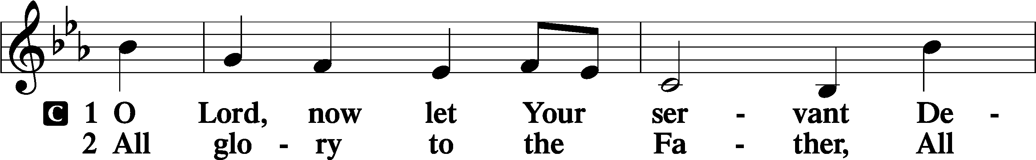
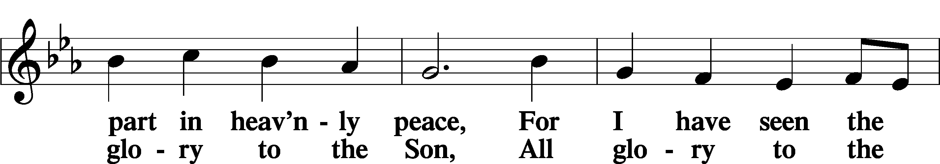
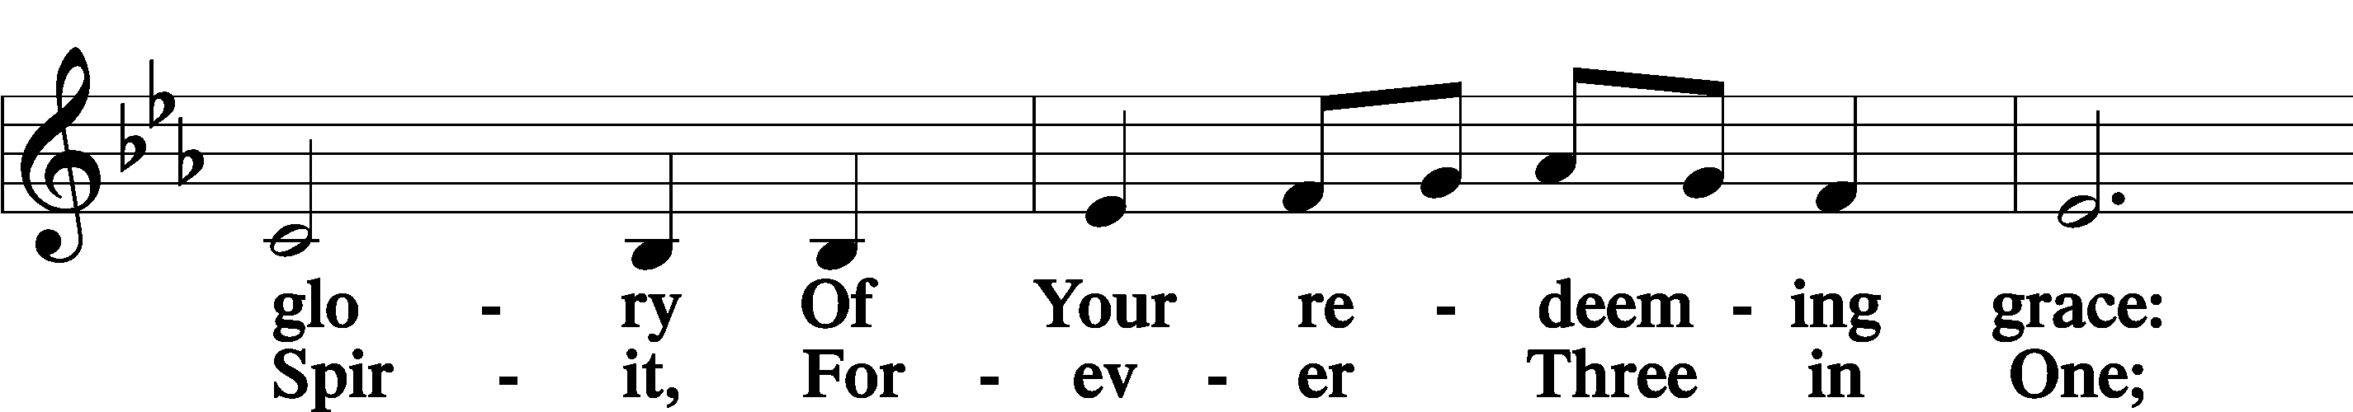
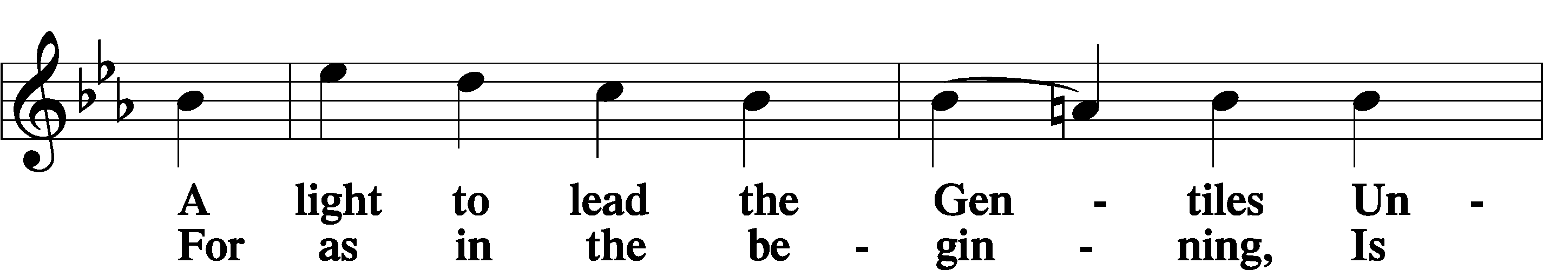
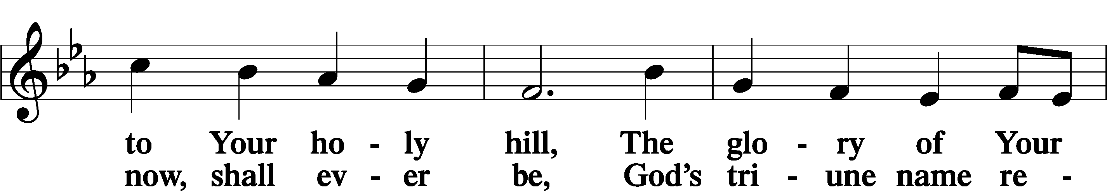
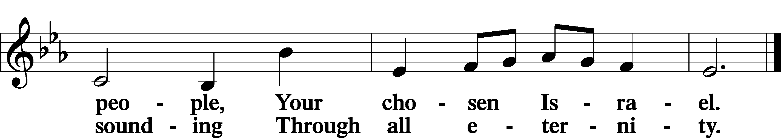

POST COMMUNION COLLECT
P Let us pray.
O God the Father, the fountain and source of all goodness, who in loving-kindness sent Your only-begotten Son into the flesh, we thank You that for His sake You have given us pardon and peace in this Sacrament, and we ask You not to forsake Your children but always to

rule our hearts and minds by Your Holy Spirit that we may be enabled constantly to serve You; through Jesus Christ, Your Son, our Lord, who lives and reigns with You and the Holy Spirit, one God, now and forever.
C Amen.

BENEDICAMUS LSB 212
P Let us bless the Lord.
C Thanks be to God.
BENEDICTION
P The Lord bless you and keep you.
The Lord make His face shine on you and be gracious to you.
The Lord look upon you with favor and T give you peace.
C Amen.

Please be seated

CLOSING HYMN
Take My Life and Let It Be LSB 783
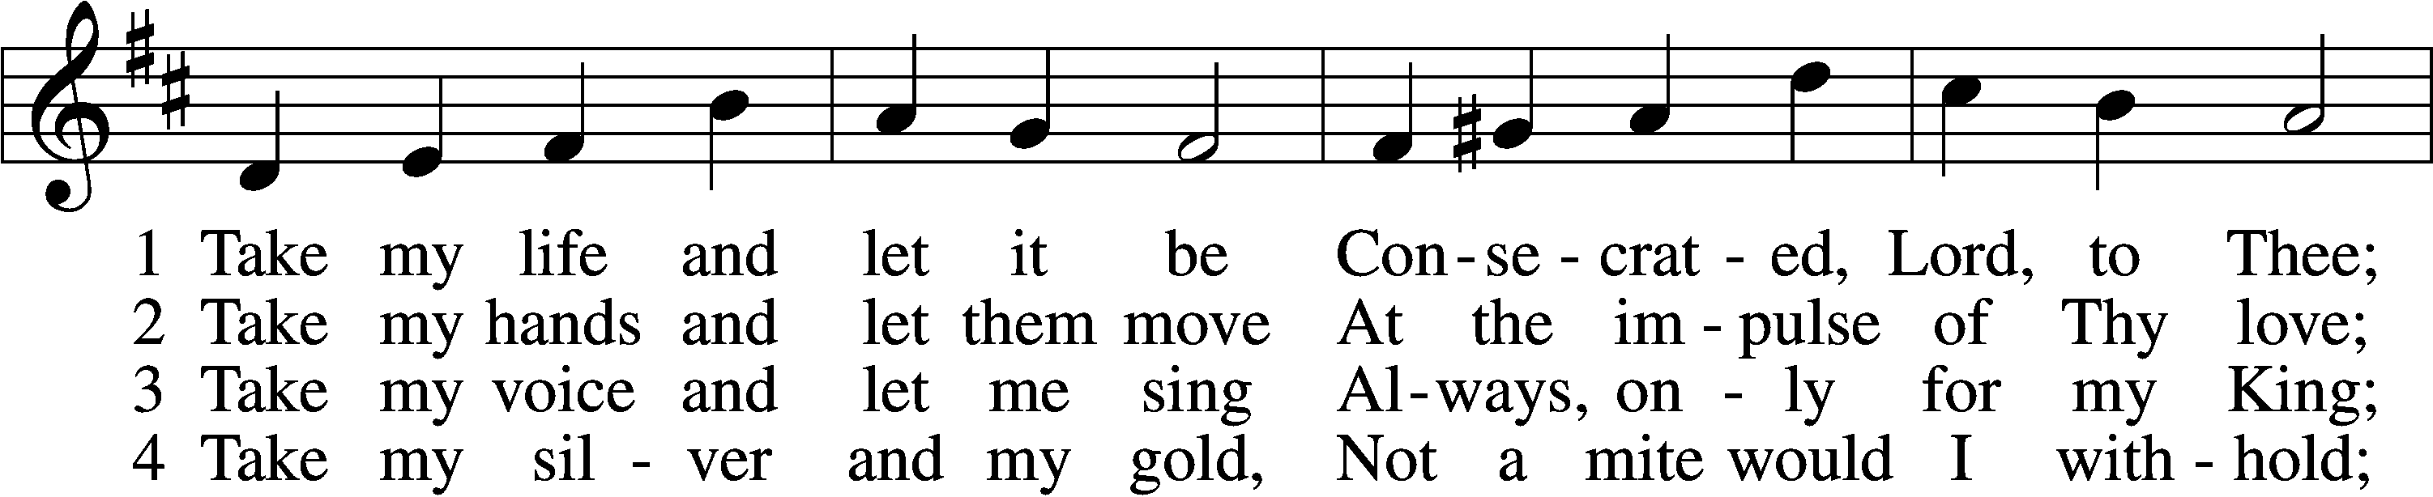
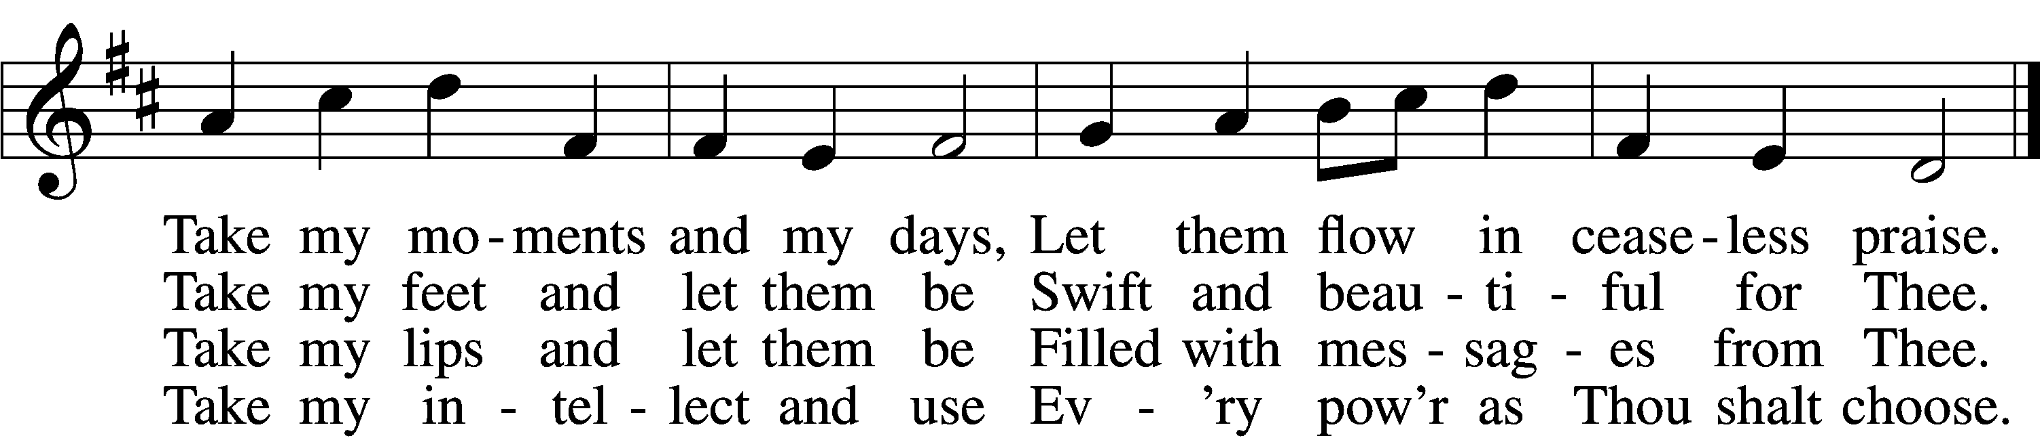

5 Take my will and make it Thine,
It shall be no longer mine;
Take my heart, it is Thine own,
It shall be Thy royal throne.

6 Take my love, my Lord, I pour
At Thy feet its treasure store;
Take myself, and I will be
Ever, only, all for Thee.
Text and tune: Public domain

ANNOUNCEMENTS and SENDING WORDS
P We go to live for Jesus!
C We go to share His love!

Acknowledgments
Unless otherwise indicated, Scripture quotations are from the ESV® Bible (The Holy Bible, English Standard Version®), copyright © 2001 by Crossway, a publishing ministry of Good News Publishers. Used by permission. All rights reserved. Created by Lutheran Service Builde

Next Week’s Readings
Old Testament: Jeremiah 1:4-10 (17-19)
Epistle: 1 Corinthians 12:13b-13:13
Holy Gospel: Luke 4:31-44

SERVING in GODS HOUSE TODAY
Pastor: Rev. Paul Schneider
Elder: Ron Tesolin
Ushers: Wally & Pam Beasinger
Greeters: Sterling & Jeanine Boldrey
Coffee Servers:
Counters: Karl Scheiterlein, Nancy Ely
Altar Care: Linda West
Organ/Keyboard: Tom & Jean Beach
Children’s Talk: Nancy Ely
PRAYERS
Please contact the office with updates to the prayer list. People will remain on the prayer list for 4 weeks before being removed. If they need to remain on the list, please keep Elaine informed and of any updates. This will help us to have a more accurate list. Thanks for your cooperation.

REMEMBER IN YOUR PRAYERS
Those who continue to grieve the passing of loved ones, Family of Richard Sherman, Family of Bob Breen, Family of Deb Borowiak, and the Family of Angie Ward.
Those with upcoming surgery:
Those recovering from surgery: Jennifer Martin.
Those with health concerns: Tiffany Amsdill, Amy and Jim, Laurie Breen, Hope Buchinger, Karen Christoff, Bridget Cook, Brenda Hart, Robert Lincoln , Leslie Martin, Eleanor Raether, Beth Smith, Rod Taylor, and Lyle Yingling.
Those diagnosed with cancer: Leah Eicher, Rachel Frisch, Joe Gibson, Hope Osantowski
Those under Hospice Home Care: Ruth Luebs, and Ken Williamson.
BIRTHDAYS:
Heather Appold
Abbie Trahin
ANNIVERSARIES;
NONE
MESSAGES

ALTAR FLOWERS today are given to the glory of God for the home coming of Rich Sherman and Vi Erat who passed away this past week.

MEMBER & GUEST CARDS: If you have not filled out a member/guest card, please take the time to fill one out and place it in the plate behind the back pews in our sanctuary.

WEDNESDAY MORNING BIBLE STUDY, 10:00am in the fellowship hall with Pastor Ken Bernthal.

GREETING CARDS If you are in need of some greeting cards, we carry an array of them in the cabinet in the library. The cost of the cards is posted on the cabinet. The money collected from the cards goes to LWML to help support Missions.

CANCER and FRIENDS SUPPORT GROUP: Will be meeting in January 25th... We will be having a guest speaker from OCCOA. Please remember Cancer & Friends Support Group is not just for people going through treatment, or survivors, we are also here for caregiver, spouse, children, and friends. There are times when we can all use someone to talk to during those difficult times. If there is any subject you would like to discuss with me you call or text or at 989-350-4391. Hope you will join us.

CRAFT DAY-Card Making: Saturday March 5th @ 1pm we will start a craft day. Will have a choice of 8 cards to make and you will be working one on one with a card maker. The cost for this session is $20.00. If you want to make the cards and have a problem with the cost let Elaine in the office know. Please do not let cost make you shy away from coming, talk to Elaine we have another group that will help with the cost. This is the first time we are doing card making and have to get the kinks out of it. The group is limited to 20 people. Sign up sheet is in the narthex on the wall.
BACK HALLWAY: If you had anything on the coat racks or floor in the back hallway it has been taken down stairs and put on a table. If it is for a group you teach or are in charge of, please put it in its proper place either in your room on downstairs, there are shelfs down stairs to use just label the shelf you use.
CONGREGATIONAL MEETING: The Congregational Annual Report meeting will be held on February 6, 2022 after the church service. Please mark this date on your calendar.
NOISY OFFERING: Today we will have a “noisy offering” to benefit the Otsego County Food Pantry. Buckets are on the tables behind the pews as you come in, we ask that you consider dropping your pocket change in the buckets as you pass by them. All funds collected in these buckets will go to the Otsego County Food Pantry.
KUT-UPS will be meeting Monday January 24th at 10am in the fellowship hall.

THIS WEEK AT TRINITY
January 23 Sunday
9:00 am Worship Service - Holy Communion – Rev. Paul Schneider
Noisy offering
10:00 am Fellowship & Coffee Hour
10:30 am Sunday Morning Bible Study W/ Dr. Tom Beach

January 24 Monday
10:00 am Kut ups (Fellowship Hall)
7:00 pm Choir

January 25 Tuesday
5:30 pm Cancer & Friends Support Group (Fellowship Hall)

January 26 Wednesday
10:00 am Wednesday Morning Bible Study W/ Pastor Ken Bernthal

January 27 Thursday
7:00 pm Erat’s Home Bible Study Group

January 28 Friday

January 29 Saturday

January 30 Sunday
9:00 am Worship Service - Holy Communion – Rev. Ken Bernthal
10:00 am Fellowship & Coffee Hour
10:30 am Bible Study with Dr. Tom Beach (Tutoring Room)

